

Functional Design Document (FDD)
Vertex IP Correspondence Automation Agent

Client | Vertex Pharmaceuticals
Project | IP Correspondence Automation
Solution Platform | Microsoft Power Platform (Power Automate, Outlook, Dataverse/SharePoint)
Document Type | Functional Design Document (FDD)
Version | 1.0 Draft
Prepared By | Hai Nguyen
Date | October 2026

Internal Review Notes
The notes below were identified during a format/content pass of this draft. They are commentary for the author’s review only — remove this section before sharing externally.
- Section 11 "Audit Fields" lists field names only; consider adding a short description/format column for each field (e.g. expected values for "Processing Result", "Exception Type").
- Section 12 "Report Schedule" states the send time is "Configurable" but does not name the configuration mechanism (e.g. environment variable, Dataverse setting, Flow trigger recurrence) — worth adding for implementers.
- The Daily Report tables in Section 12 (Executive Summary, New Folders, Filing Activity, Exceptions, Normalization Activity) are structural templates with no sample data — confirmed intentional (populated at runtime), but a one-line note under each clarifies this for reviewers unfamiliar with the design.
- No Revision History or Approvals section exists yet — recommended before this moves from Draft to a reviewed baseline.
- Several matter-prefix examples (Section 5) and normalization examples (Section 6) are illustrative only — confirm with Vertex IP Operations that the prefix list (VPI, ALP, EXO, MOD, SEM, VIA, VMN) is complete and will not require future additions without a change request.

Table of Contents
Right-click here and choose "Update Field" to generate the table of contents.

1. Document Purpose
This Functional Design Document defines the end-to-end functional behavior of the Vertex IP Correspondence Automation solution. The solution automates the classification, organization, and filing of intellectual property correspondence received via Outlook email.
The system identifies patent family references from incoming correspondence, files emails into the appropriate folder structure, creates folders when required, manages exceptions, and generates operational reporting.

2. Business Overview
Today, Vertex IP Operations manually:
- Review incoming emails
- Identify patent family references
- Locate family folders
- Create folders when necessary
- Move emails to proper locations
- Track filing exceptions
This process consumes significant operational effort and relies heavily on user knowledge of folder structures and reference formats.
The proposed solution automates these activities while preserving business oversight for ambiguous scenarios.

3. Solution Overview

High-Level Process
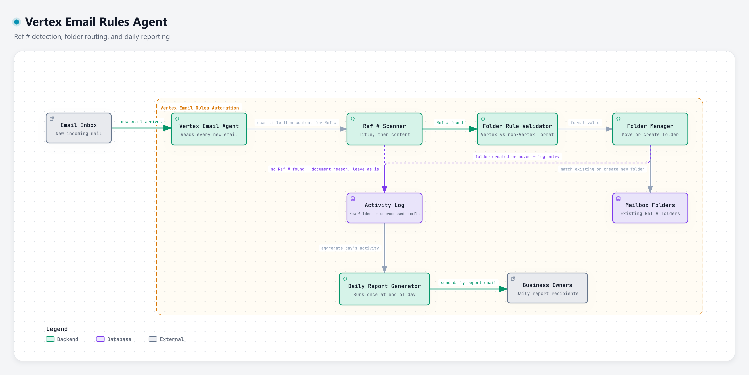

4. Functional Scope

Included

Email Processing
- New emails
- Replies
- Acknowledgements

Reference Extraction
- Subject
- Current message body
- Quoted message history

Folder Management
- Folder discovery
- Folder creation
- Folder validation

Filing
- Move email to family folder
- Audit processed activity

Reporting
- Daily operational report
- Exception reporting

Excluded (Phase 1)
- Attachment OCR
- Attachment content extraction
- iManage integration
- Patent docketing activities
- Patent workflow management
- Legal review activities

5. Reference Identification

Supported Family References
Examples include:
- 1 VPI-18-114
- 2 ALP-25-001
- 3 EXO-22-115
- 4 MOD-24-220
- 5 SEM-26-788
- 6 VIA-05-201
- 7 VMN-19-114
Based on current samples, the solution shall support the matter prefixes:
- VPI
- ALP
- EXO
- MOD
- SEM
- VIA
- VMN

Reference Search Order
The system searches in the following sequence:

Priority 1
Email Subject
Example:
1 Notice of Allowance | Your Ref: SEM-26-788

Priority 2
Current Email Body
Example:
1 Client Reference: SEM-26-788

Priority 3
Quoted Email Chain
If no reference is detected in:
- Subject
- Current body
the system shall inspect the most recent quoted correspondence.

6. Reference Normalization
The system shall standardize references before matching.

Examples
Detected Value | Normalized Value
VPI/19-117 | VPI-19-117
VPI 19 117 | VPI-19-117
vpi-19-117 | VPI-19-117
VPI-18-114 US PRV1 | VPI-18-114
SEM-25-786 US | SEM-25-786

Normalization Rules
- Convert to uppercase
- Convert "/" to "-"
- Convert spaces to "-"
- Remove country codes
- Remove subcase suffixes
- Trim extra spaces

7. Folder Structure

Expected Folder Architecture
1 Inbox
2 ├─ VPI-18-114
3 ├─ VPI-19-117
4 ├─ SEM-26-788
5 ├─ ALP-21-005
6 └─ VIA-05-201
Family folders are the filing destination.
Country-specific folders are ignored for routing purposes.
Example:
1 VPI-18-114 US PRV1
Routes to:
1 VPI-18-114

8. Automated Filing Rules

Rule 1 – Single Valid Family
Condition:
1 One valid family detected
Action:
1 File automatically

Rule 2 – Folder Exists
Condition:
1 Folder located
Action:
1 Move email to folder

Rule 3 – Folder Missing
Condition:
1 Valid family detected
2 +
3 Folder not found
Action:
1 Create family folder
2 Move email
3 Record activity

9. Exception Rules

Exception 1 – No Reference Found
Condition:
1 No valid reference detected
Action:
- Leave email in Inbox
- Add to exception queue
- Include in daily report

Exception 2 – Multiple Family References
Example:
1 VPI-17-127, 2 VPI-17-128
Action:
- No auto-filing
- Route for manual review

Exception 3 – Subject/Body Conflict
Example:
Subject:
1 VPI-19-117
Body:
1 VPI-20-015
Action:
- Do not determine priority automatically
- Route for manual review

Exception 4 – Conflicting References in Quoted History
Example:
1 Latest quoted:
2 VPI-19-117
3
4 Older quoted:
5 VPI-20-015
Action:
- Create exception
- Require manual review

Exception 5 – Invalid Format
Example:
1 VPI-ABC-123
Action:
- Leave email untouched
- Add exception record

Exception 6 – Attachment Only
Example:
Reference appears solely within a PDF attachment.
Action:
- Do not process in Phase 1
- Create exception

10. Folder Creation Process
When a family folder does not exist:

Step 1
Create folder
Example:
1 SEM-26-788

Step 2
Record creation activity

Step 3
Move email into folder

Step 4
Capture audit details

11. Audit Logging
Every processed email shall generate an audit entry.

Audit Fields
- Message ID
- Sender
- Subject
- Reference
- Folder
- Processing Result
- Timestamp
- Exception Type
Each field is captured per processed email; descriptions to be finalized during build.

12. Daily Report Functional Design

Report Schedule
Configurable
Example:
1 5:00 PM Eastern

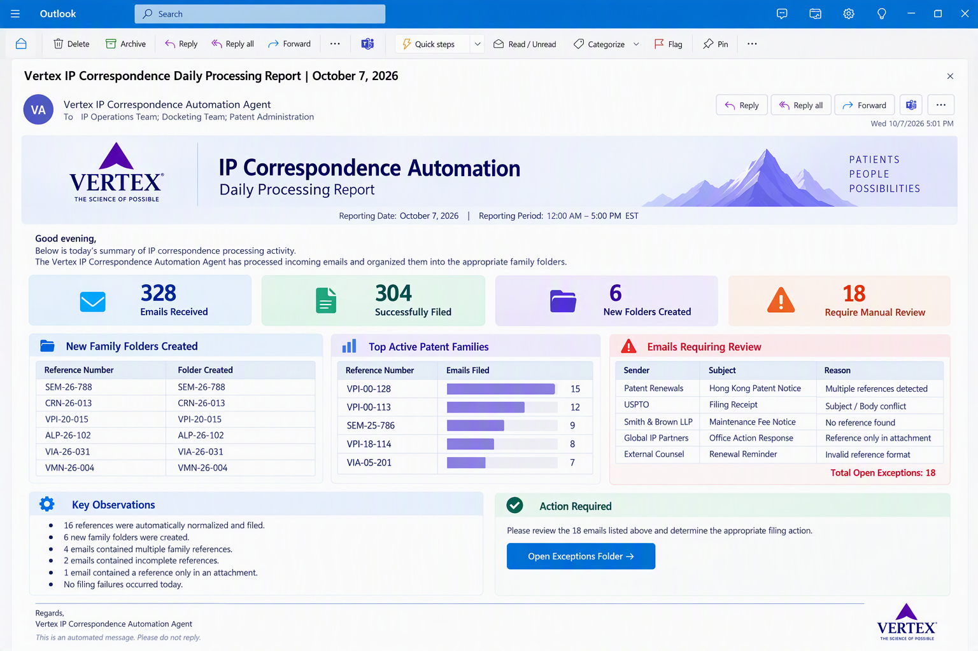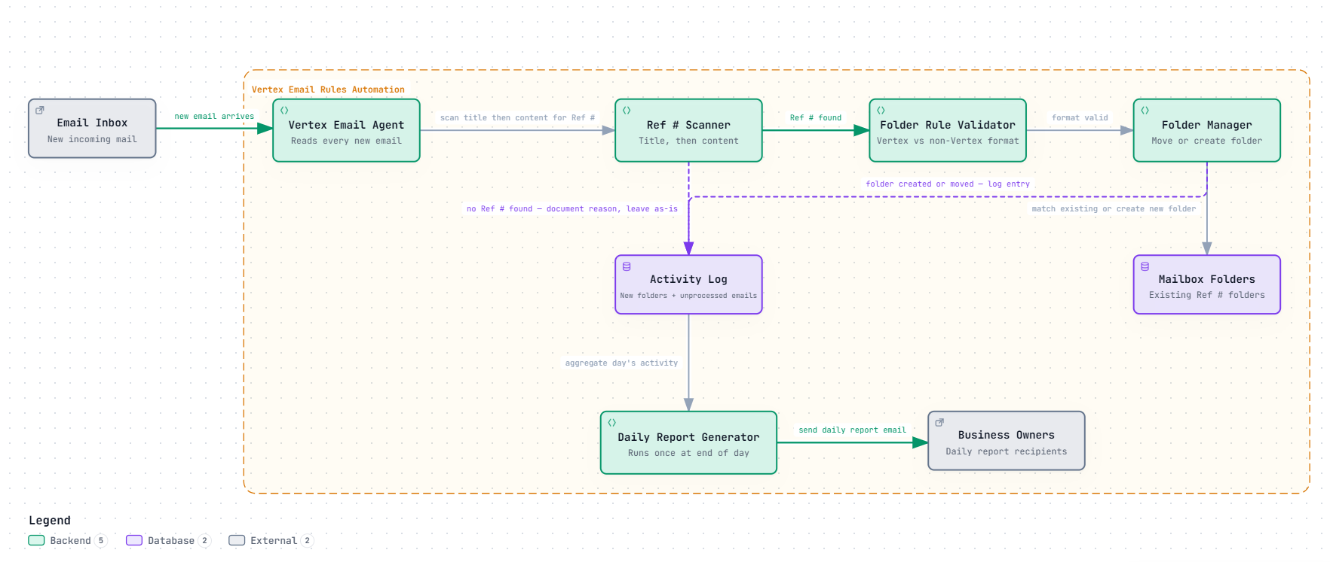

14. Non-Functional Requirements

Performance
- Process emails within minutes of receipt

Accuracy
- Target >95% filing accuracy

Security
- Operate within Vertex-approved Microsoft 365 environment

Auditability
- Every action logged

Scalability
- Support additional IP teams and family types

15. Future Phase Enhancements

AI-Assisted Reference Extraction
- Azure OpenAI
- AI Builder

Attachment Processing
- OCR
- PDF parsing
- Reference extraction from attachments

Copilot Studio Agent
Business users can ask:
- 1 Show all correspondence for SEM-26-788
2
3 Why wasn't this email filed?
4
5 What folders were created today?
6
7 List all open exceptions.

Power BI Dashboard
Operational KPIs including:
- Processing volume
- Automation success rate
- Open exceptions
- Top active patent families
- Trend analysis

Appendix – Proposed Business Decisions
Scenario | Proposed Action
One valid family | Auto-file
Folder exists | Move email
Folder missing | Create folder and move
No reference | Leave in Inbox
Multiple families | Manual review
Subject/body conflict | Manual review
Invalid format | Manual review
Reference only in attachment | Manual review
Slash format | Normalize and process
Country suffixes | Remove for routing
Duplicate processing | Prevent re-processing
Folder rename | Do not rename automatically
This design provides a complete Phase 1 MVP blueprint that can be implemented using Outlook, Power Automate, and Dataverse/SharePoint while establishing a clear roadmap toward Copilot Studio and AI-enabled IP operations.

